SUMO promotes longevity and maintains mitochondrial homeostasis during ageing in Caenorhabditis elegans

Andrea Princz^{1,2}, Federico Pelisch³ and Nektarios Tavernarakis^{1,4}

1 Institute of Molecular Biology and Biotechnology, Foundation for Research and Technology – Hellas, Heraklion, Greece
2 Department of Biology, University of Crete, Heraklion, Greece
3 Centre for Gene Regulation and Expression, Sir James Black Centre, School of Life Sciences, University of Dundee, Dundee, Scotland, UK
4 Department of Basic Sciences, Faculty of Medicine, University of Crete, Heraklion, Greece

Supplemental Information

Supplemental Figures S1-S6
Supplemental Table S1

Supplemental figures & legends

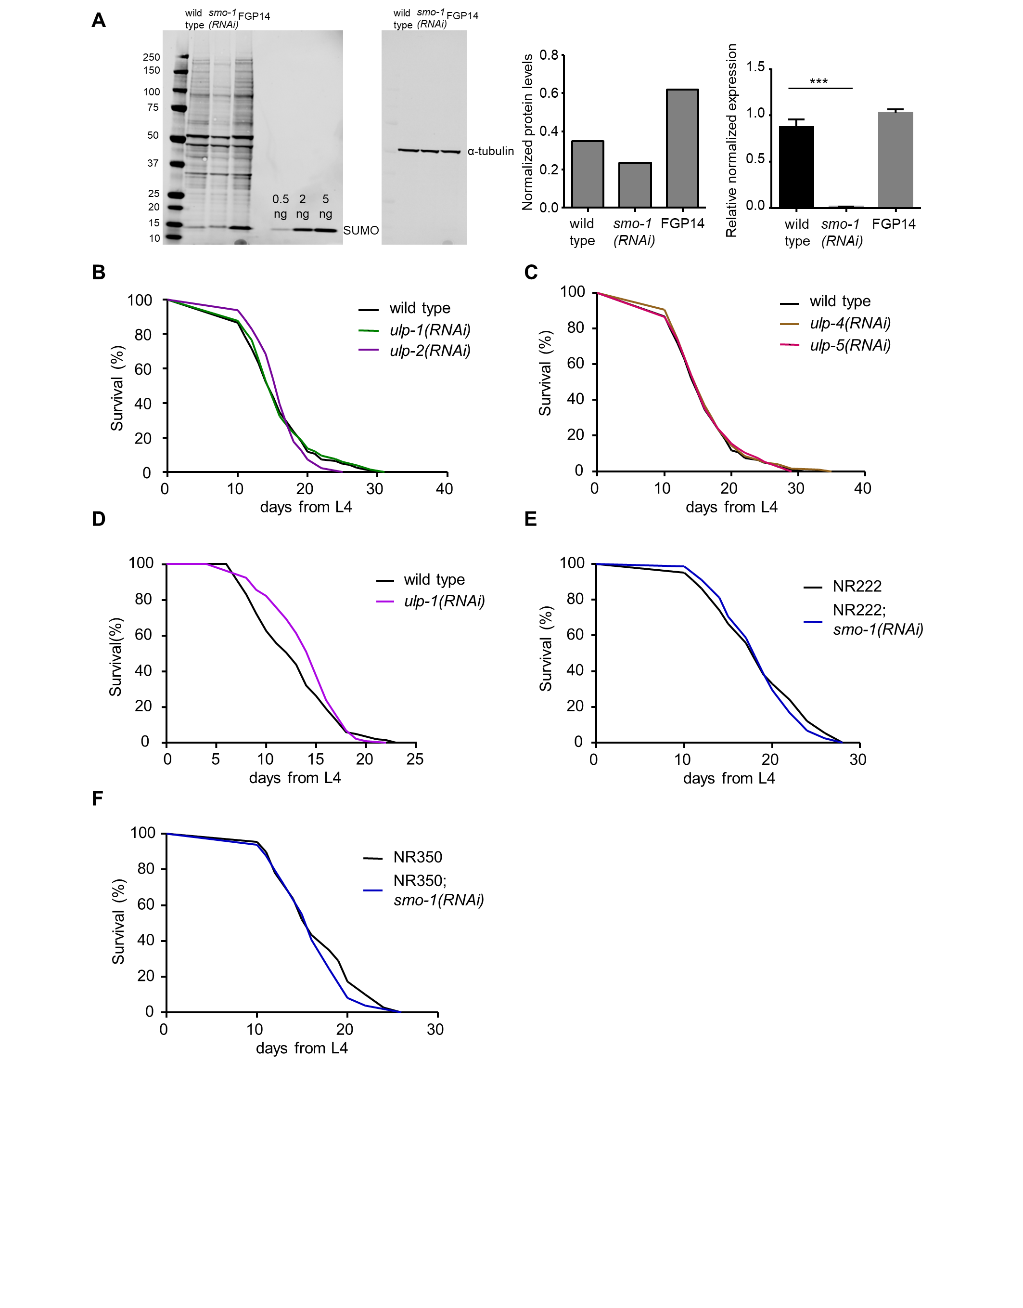

Figure S1. SUMO proteases do not influence lifespan in wild type animals.
A Left panel: Western blot showing SUMO protein levels in wild type, smo-1(RNAi) and smo-1 overexpressing (FGP14) background. Protein levels were normalized to α-tubulin. N=1.
Right panel: mRNA levels are diminished under smo-1(RNAi) conditions (***p<0.001, unpaired t-test). Error bars, S.E.M.
B-C Removal of SUMO proteases (ulp-1-5) does not have an effect on wild type lifespan at 20°C.
D Reduced ulp-1 expression extends the lifespan of wild type animals at 25°C.
E-F Muscle (NR350) or hypodermis (NR222) specific knock-down of smo-1 does not have an effect on lifespan. Lifespan assays were carried out at 20°C. Lifespan values are given in Table S1.

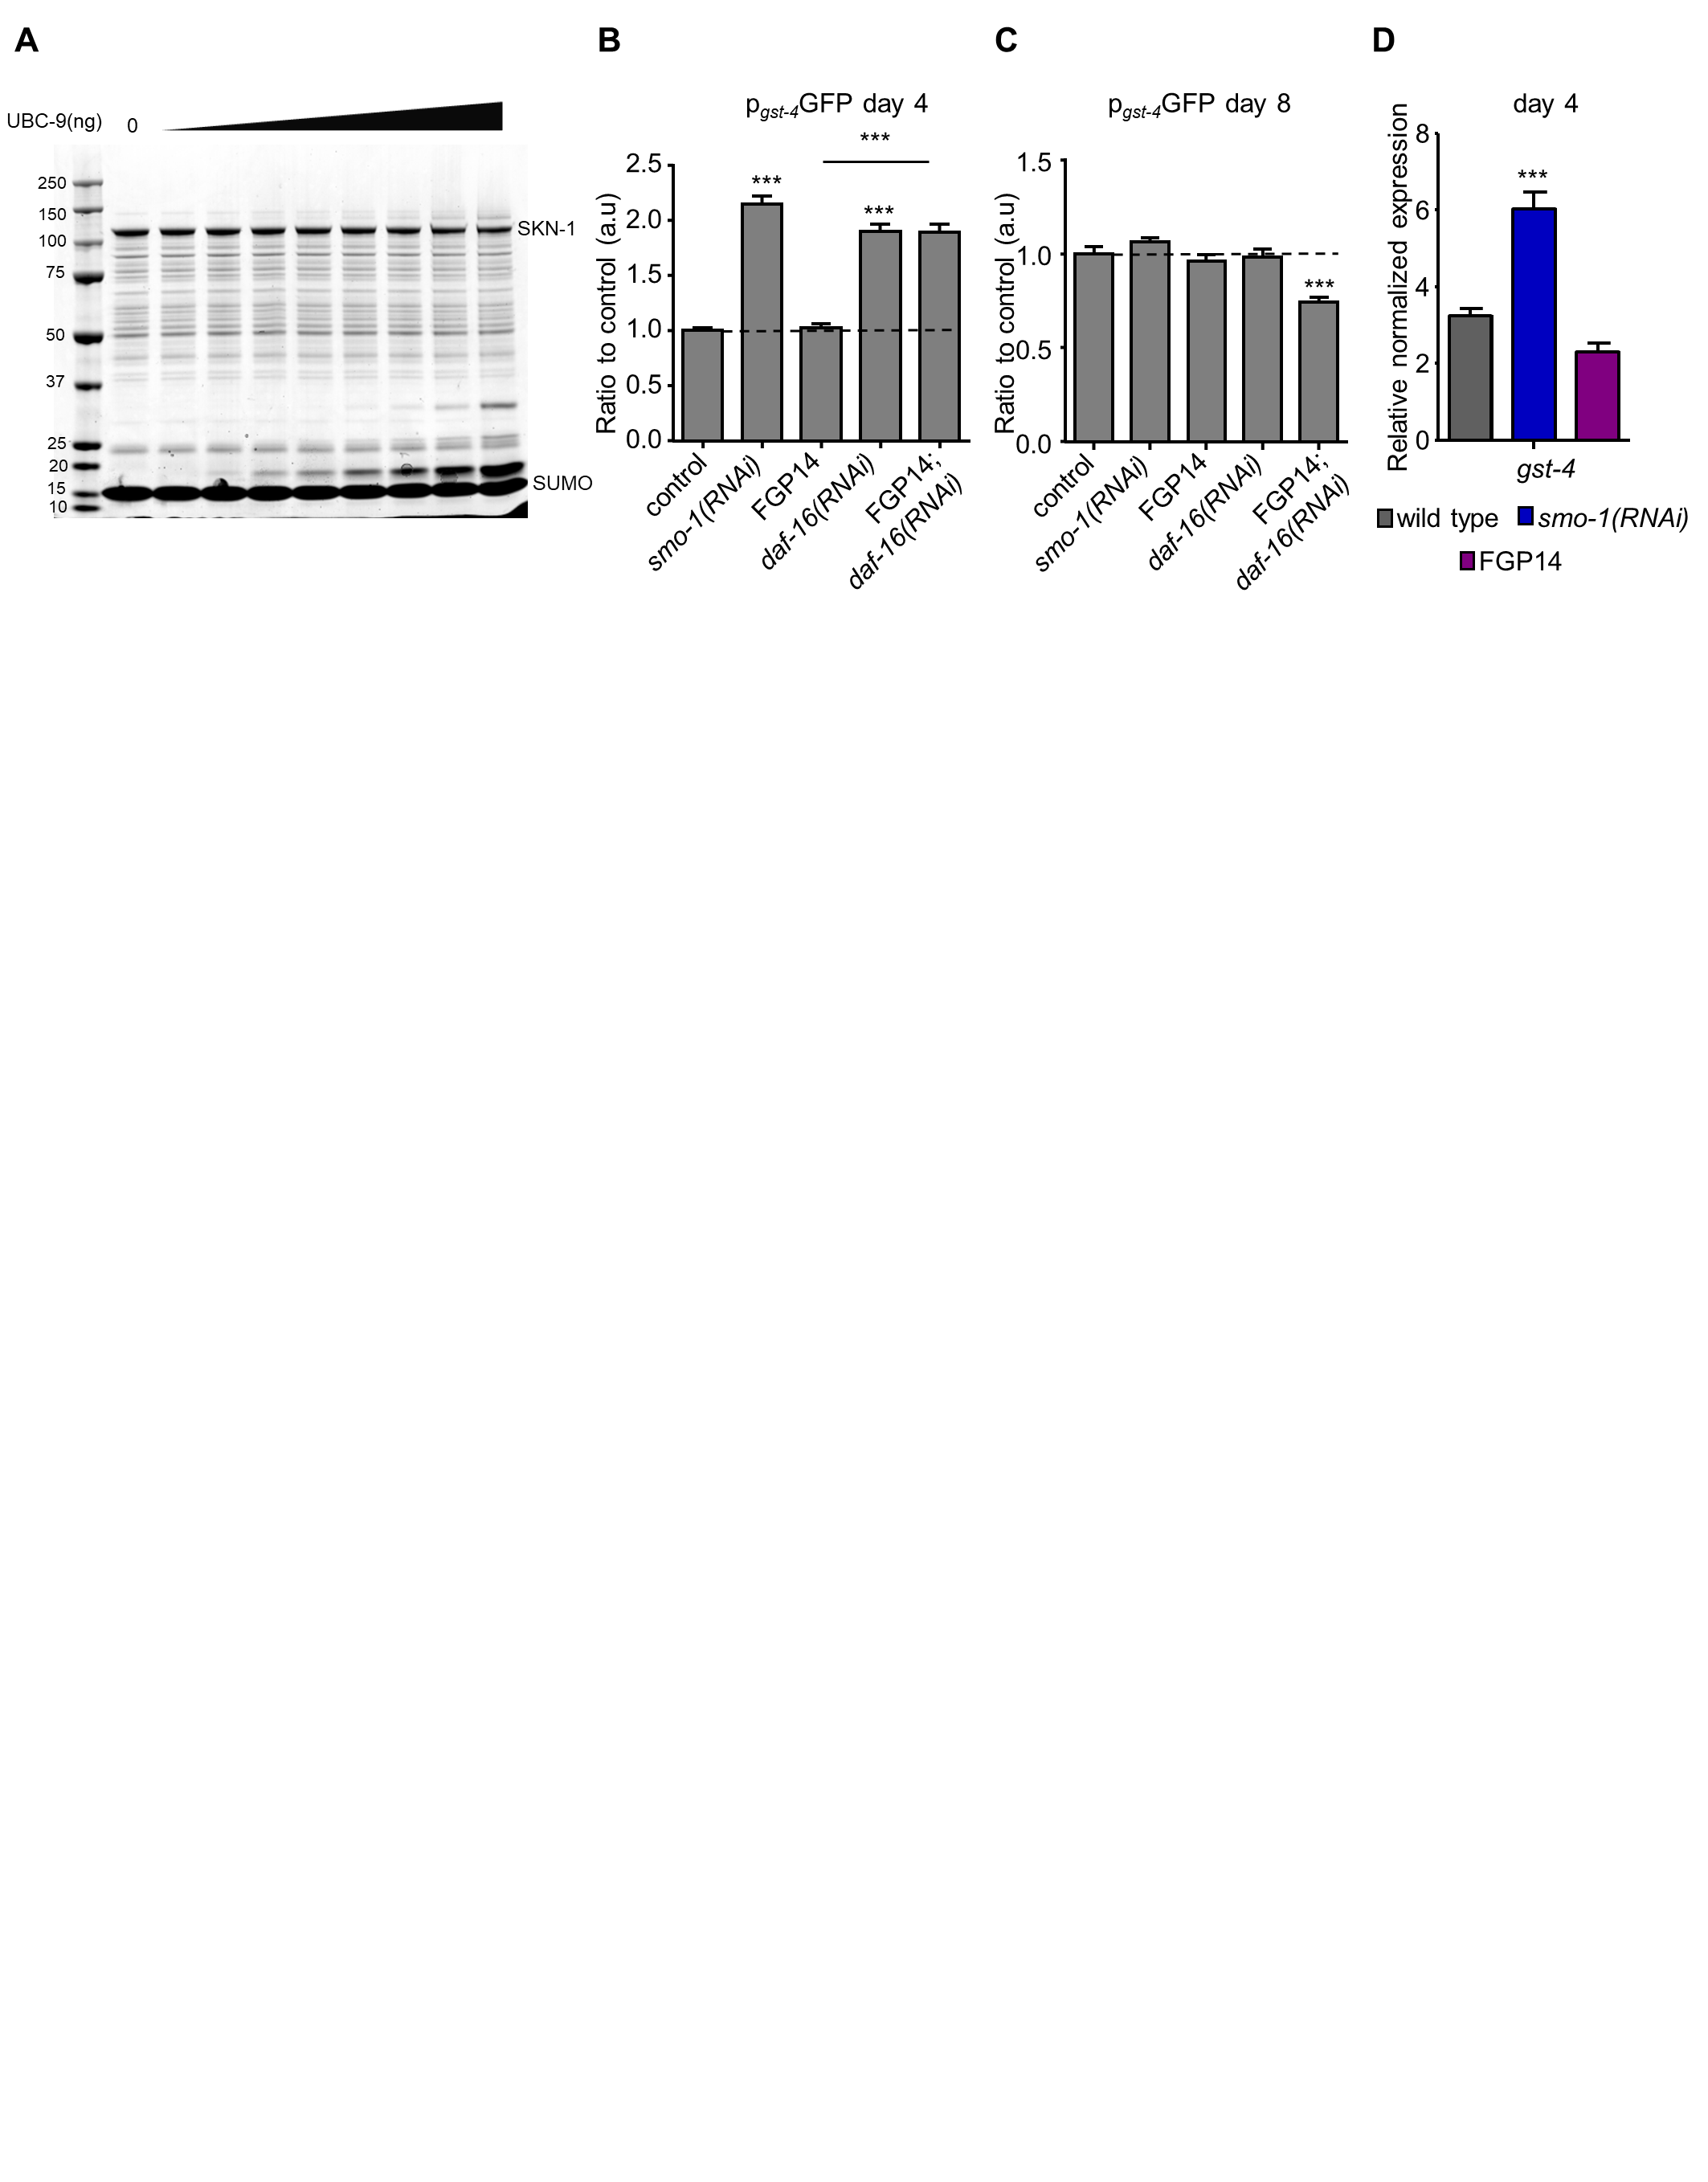

Figure S2. SKN-1 is not a direct SUMO target.
A In vitro SUMOylation assay using MBP tagged SKN-1.
B-C p_{gst-4}GFP expression is increased upon smo-1(RNAi) and daf-16(RNAi) but does not change when smo-1 is overexpressed in day 4 animals and this change is not observable in day 8 animals (n=100, ***p<0.001, one-way ANOVA).
D The mRNA levels of gst-4 are increased when we knock-down smo-1, but there is no change upon smo-1 overexpression in day 4 animals (***p<0.001, unpaired t-test). Error bars, S.E.M.

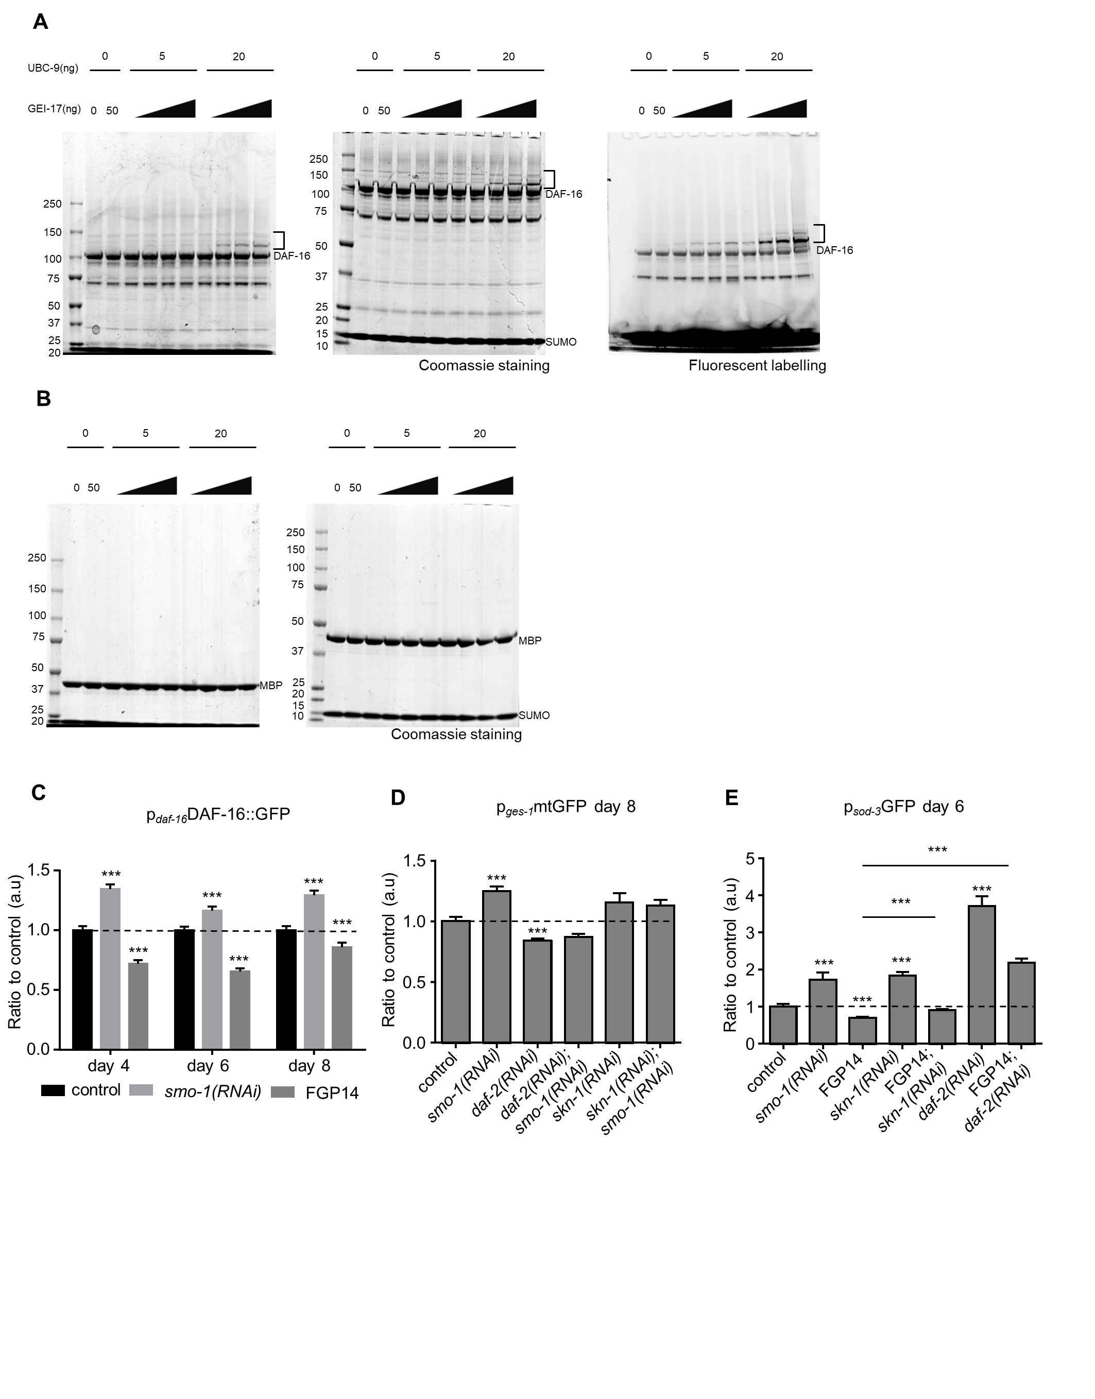

Figure S3. SUMOylation of DAF-16 modulates stress responses.
A In vitro SUMOylation assay with MBP tagged DAF-16. Brackets indicate the SUMO modified form of DAF-16. Left panel: 3-8% Tris-Acetate gel, Coomassie staining; middle panel: 4-12% Bis-Tris gel, Coomassie staining; right panel: fluorescent labelling of the 3-8% Tris-Acetate gel.
B In vitro SUMOylation assay with the MBP tag alone. Left panel: 3-8% Tris-Acetate gel, right panel: 4-12% Bis-Tris gel.
C Decreasing smo-1 expression increases p_{daf-16}DAF-16::GFP expression, while overexpression of smo-1 reduces it (n=100, ***p<0.001, unpaired t-test).
D p_{ges-1}mtGFP expression is increased on smo-1(RNAi) in wild type background in day 8 animals (n=100, ***p<0.001, unpaired t-test).
E p_{sod-3}GFP expression is up-regulated upon smo-1(RNAi), skn-1(RNAi) and daf-2(RNAi) in day 6 animals. The overexpression of smo-1 decreases the expression of sod-3 (n=75, ***p<0.001, unpaired t-test). Error bars, S.E.M.

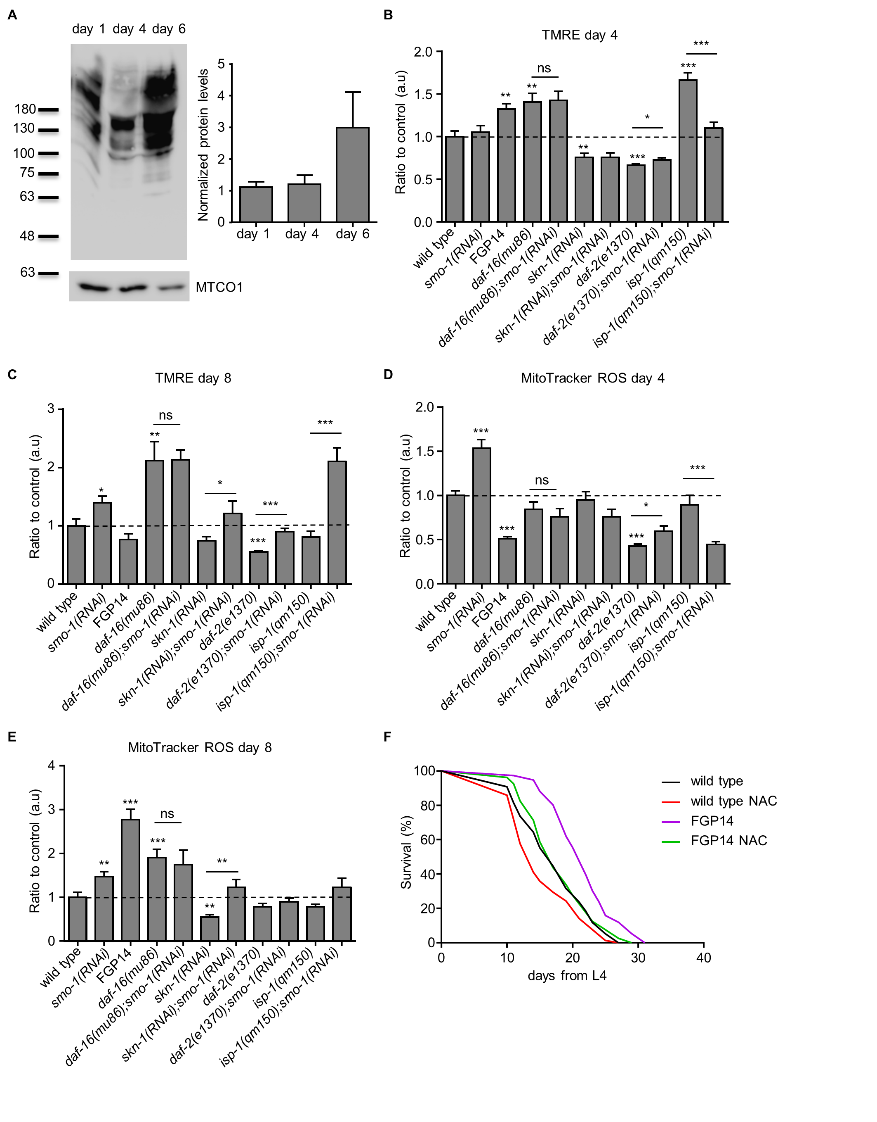

Figure S4. SUMO levels increase in the mitochondrial fraction and SUMO alters mitochondrial function.
A Western blot analysis of SUMOylated proteins in the mitochondrial fraction in day 1, 4 and 6 wild type animals (N=4). Protein levels were normalized to MTCO1.
B-C TMRE staining declines during ageing in wild type but not smo-1(RNAi) treated animals, and this change is DAF-16 dependent (n=100, *p<0.05, **p<0.01, ***p<0.001, unpaired t-test).
D-E Mitochondrial ROS production, measured by MitoTracker ROS, is increased when we knockdown smo-1 and this effect is also DAF-16 dependent (n=75, *p<0.05, **p<0.01, ***p<0.001, unpaired t-test). Error bars, S.E.M.
F Treatment with the antioxidant NAC (N-acetyl cyteine) abrogates the long lifespan of smo-1 overexpressing animals. Lifespan assays were carried out at 20°C. Lifespan values are given in Table S1.

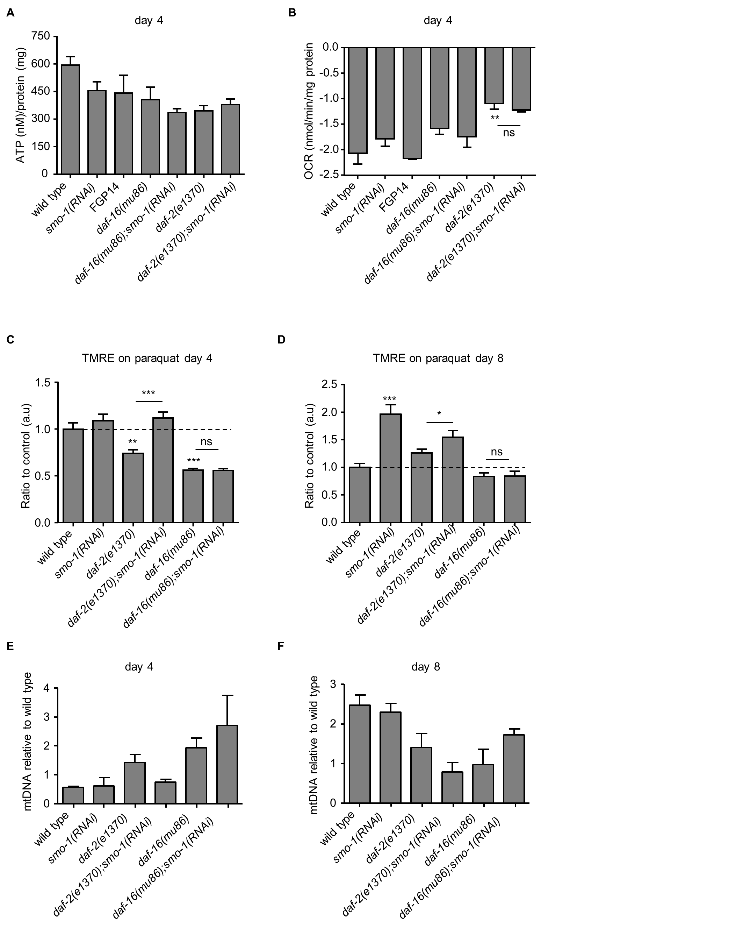

Figure S5. SUMO regulates mitochondrial content during ageing.
A ATP levels do not change in 4-day old animals upon smo-1 knockdown. Error bars, S.E.M.
B Oxygen consumption rates are not affected by smo-1 depletion at day 4, while daf-2(e1370) animals exhibit lower oxygen consumption (**p<0.01).
C-D Mitochondrial content is increased during ageing upon smo-1(RNAi) in a DAF-16 dependent manner, measured by subsequent paraquat treatment and TMRE staining (n=50, *p<0.05, **p<0.01, ***p<0.001, one-way ANOVA).
E-F Mitochondrial DNA copy number, normalized to genomic DNA. smo-1(RNAi) treatment does not affect the mitochondrial DNA copy number in wild type, daf-2(e1370) and daf-16(mu86) background in day 4 or day 8 animals. Error bars, S.E.M.

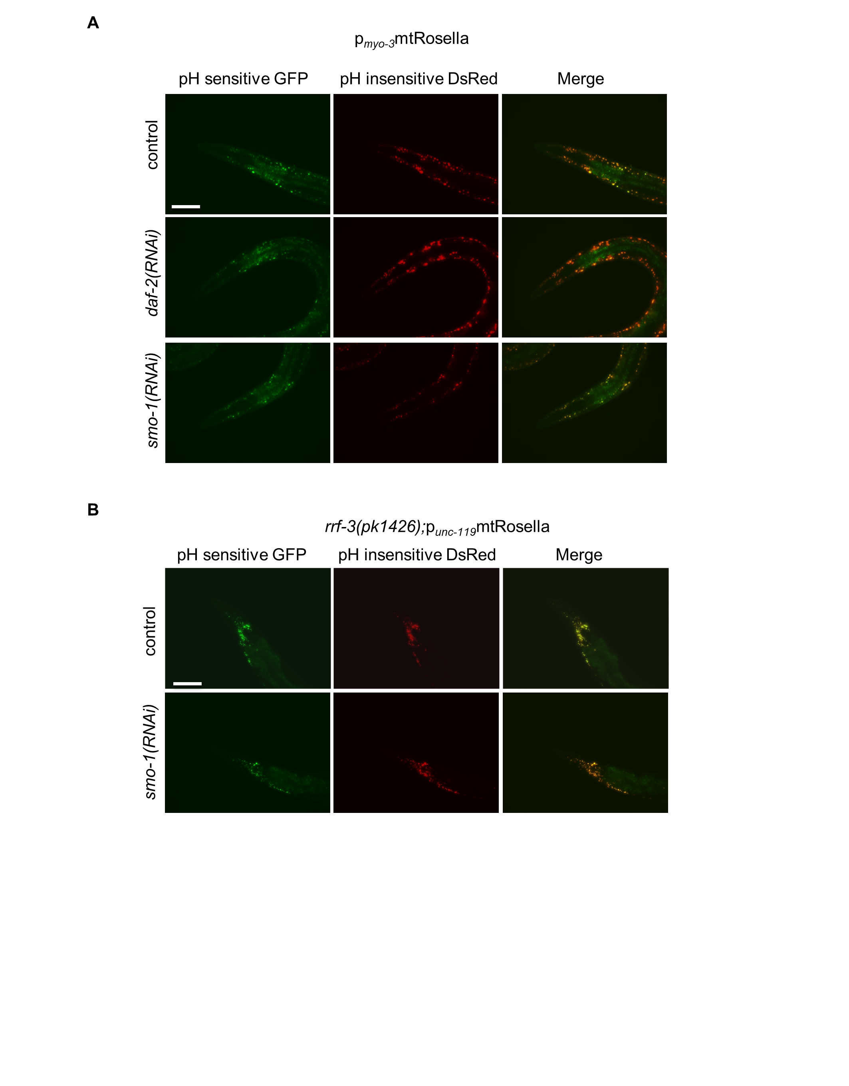

Figure S6. SUMO influences mitophagy in muscles and neurons.
A Animals expressing mitochondria targeted Rosella biosensor in body wall muscle cells. daf-2(RNAi) increases, while smo-1(RNAi) inhibits mitophagy, scale bar: 100 μm. Images were aquired using x20 objective lens.
B Mitochondria targeted Rosella biosensor, expressed in neurons. Knockdown of smo-1 induces neuronal mitophagy, scale bar: 100 μm. Images were aquired using x20 objective lens.

Table S1. Lifespan data
Unless noted otherwise, all aging experiments were performed on plates seeded with HT115(DE3) E. coli bacteria, carrying the indicated RNAi plasmid constructs. (Maximum lifespan shown is the median lifespan of the longest-lived 10% of the animals assayed. P values were calculated using the log-rank test, as described in Methods.)
Strain | Median lifespan | Deaths | Censored events | Maximum lifespan | P value | Comparison | Relevant figure
Experiment #1
wild type | 16 | 133 | 11 | 27.5
smo-1(RNAi) | 15 | 110 | 40 | 20 | <0.0001 | compared to wild type
Experiment #2
wild type | 15 | 187 | 9 | 26.5
smo-1(RNAi) | 14 | 211 | 10 | 23 | 0.0231 | compared to wild type
ulp-1(RNAi) | 15 | 197 | 8 | 27 | 0.6803 | compared to wild type | graph shown in Figure S1B
ulp-4(RNAi) | 15 | 200 | 7 | 28.5 | 0.5087 | compared to wild type | graph shown in Figure S1C
ulp-5(RNAi) | 15 | 227 | 8 | 26.5 | 0.7478 | compared to wild type | graph shown in Figure S1C
daf-16(mu86) | 14 | 193 | 6 | 22.5
daf-16(mu86);smo-1(RNAi) | 14 | 219 | 8 | 22.5 | 0.7567 | compared to daf-16(mu86)
daf-2(e1370) | 37 | 200 | 5 | 55.5
daf-2(e1370);smo-1(RNAi) | 29 | 204 | 8 | 38 | <0.0001 | compared to daf-2(e1370)
daf-2(e1370);ulp-1(RNAi) | 37 | 209 | 11 | 64 | 0.4889 | compared to daf-2(e1370)
VP303 | 20 | 210 | 15 | 25
VP303;smo-1(RNAi) | 18 | 227 | 10 | 23.5 | 0.0031 | compared to VP303
NR222 | 18 | 225 | 8 | 23.5
NR222;smo-1(RNAi) | 18 | 227 | 13 | 23.5 | 0.163 | compared to NR222
NR350 | 16 | 155 | 10 | 21.5
NR350;smo-1(RNAi) | 16 | 152 | 12 | 21.5 | 0.9375 | compared to NR350
Experiment #3
wild type | 15 | 169 | 3 | 26
ulp-4(RNAi) | 17.5 | 190 | 6 | 26 | 0.0031 | compared to wild type
Experiment #4
wild type | 17 | 220 | 8 | 27.5
smo-1(RNAi) | 15 | 226 | 14 | 20.5 | <0.0001 | compared to wild type
ulp-1(RNAi) | 17 | 236 | 9 | 26.5 | 0.2153 | compared to wild type
ulp-4(RNAi) | 17 | 177 | 8 | 27 | 0.8859 | compared to wild type
VP303 | 20 | 216 | 12 | 27
VP303;smo-1(RNAi) | 20 | 183 | 8 | 25 | 0.009 | compared to VP303
NR222 | 18 | 230 | 9 | 28
NR222;smo-1(RNAi) | 19 | 270 | 15 | 26.5 | 0.2915 | compared to NR222
NR350 | 16 | 199 | 12 | 27
NR350;smo-1(RNAi) | 16 | 168 | 10 | 22.5 | 0.0235 | compared to NR350
Experiment #5
wild type | 17 | 153 | 3 | 24
smo-1(RNAi) | 13 | 174 | 7 | 21 | <0.0001 | compared to wild type
TU3401 | 14 | 211 | 3 | 22
TU3401;smo-1(RNAi) | 13 | 206 | 5 | 18.5 | <0.0001 | compared to TU3401
VP303 | 17 | 102 | 5 | 26
VP303;smo-1(RNAi) | 16 | 130 | 5 | 23 | 0.0038 | compared to VP303 | graph shown in Figure 2C
NR222 | 18 | 183 | 7 | 27
NR222;smo-1(RNAi) | 18 | 211 | 10 | 26 | 0.3457 | compared to NR222 | graph shown in Figure S1E
NR350 | 16 | 69 | 8 | 24
NR350;smo-1(RNAi) | 16 | 49 | 5 | 23 | 0.3075 | compared to NR350 | graph shown in Figure S1F
Experiment #6
wild type | 16 | 153 | 7 | 23
smo-1(RNAi) | 14 | 169 | 12 | 19 | <0.0001 | compared to wild type
ulp-1(RNAi) | 16 | 156 | 6 | 24 | 0.2972 | compared to wild type
ulp-2(RNAi) | 16 | 177 | 8 | 22.5 | 0.999 | compared to wild type | graph shown in Figure S1B
skn-1(RNAi) | 14 | 193 | 9 | 19 | <0.0001 | compared to wild type
skn-1(RNAi);smo-1(RNAi) | 15 | 178 | 11 | 18.5 | 0.0056 | compared to wild type
Experiment #7
wild type | 18 | 74 | 12 | 23
ulp-2(RNAi) | 16 | 61 | 10 | 23 | 0.5969 | compared to wild type
FGP14 | 22 | 186 | 12 | 29 | <0.0001 | compared to wild type
VP303 | 16 | 95 | 4 | 24
VP303;smo-1(RNAi) | 16 | 109 | 3 | 21 | 16 | compared to VP303
Experiment #8
wild type | 16 | 165 | 6 | 23
smo-1(RNAi) | 15 | 192 | 8 | 20 | 0.0001 | compared to wild type | graph shown in Figure 3A
skn-1(RNAi) | 15 | 201 | 8 | 21 | 0.001 | compared to wild type | graph shown in Figure 3A
skn-1(RNAi);smo-1(RNAi) | 15 | 238 | 12 | 22 | 0.0031 | compared to wild type | graph shown in Figure 3A
FGP14 | 19 | 131 | 8 | 29 | <0.0001 | compared to wild type | graph shown in Figure 3B
FGP14;daf-16(RNAi) | 18.5 | 100 | 15 | 24 | 0.0007 | compared to FGP14 | graph shown in Figure 4C
FGP14;skn-1(RNAi) | 14 | 176 | 13 | 20.5 | <0.0001 | compared to FGP14 | graph shown in Figure 3B
daf-2(e1370) | 43 | 130 | 12 | 54.5
daf-2(e1370);smo-1(RNAi) | 30 | 163 | 5 | 38 | <0.0001 | compared to daf-2(e1370)
Experiment #9
wild type | 17 | 203 | 2 | 27
smo-1(RNAi) | 15 | 193 | 12 | 21 | <0.0001 | compared to wild type
ulp-1(RNAi) | 17 | 196 | 2 | 28 | 0.6387 | compared to wild type
TU3401 | 16 | 206 | 5 | 22.5
TU3401;smo-1(RNAi) | 16 | 161 | 14 | 19.5 | 0.0018 | compared to TU3401
ife-2(ok306) | 16 | 214 | 5 | 36
ife-2(ok306);ulp-1(RNAi) | 18 | 162 | 2 | 33 | 0.0001 | compared to ife-2(ok306) | graph shown in Figure 4D
Experiment #10
wild type | 17 | 228 | 1 | 29
smo-1(RNAi) | 15 | 214 | 10 | 22 | <0.0001 | compared to wild type
ulp-1(RNAi) | 18 | 212 | 2 | 26 | 0.5279 | compared to wild type
daf-2(e1370) | 37 | 203 | 12 | 64
daf-2(e1370);smo-1(RNAi) | 27 | 220 | 3 | 41 | <0.0001 | compared to daf-2(e1370)
daf-2(e1370);ulp-1(RNAi) | 38 | 168 | 18 | 79 | 0.1617 | compared to daf-2(e1370)
Experiment #11
wild type | 20 | 213 | 5 | 30.5
smo-1(RNAi) | 15 | 195 | 4 | 25.5 | <0.0001 | compared to wild type
TU3401 | 17 | 227 | 3 | 25.5
TU3401;smo-1(RNAi) | 16 | 231 | 3 | 21 | <0.0001 | compared to TU3401 | graph shown in Figure 2D
ife-2(ok306) | 21 | 234 | 6 | 42
ife-2(ok306);ulp-1(RNAi) | 20 | 252 | 4 | 42 | 0.0198 | compared to ife-2(ok306)
Experiment #12
wild type | 18 | 202 | 6 | 29.5
smo-1(RNAi) | 18 | 255 | 13 | 24 | <0.0001 | compared to wild type
daf-16(mu86) | 14.5 | 200 | 5 | 23
daf-16(mu86);smo-1(RNAi) | 14 | 249 | 12 | 20.5 | <0.0001 | compared to daf-16(mu86)
Experiment #13
wild type | 17 | 182 | 8 | 27
smo-1(RNAi) | 15 | 206 | 9 | 20 | <0.0001 | compared to wild type
daf-16(mu86) | 15 | 177 | 8 | 20.5
daf-16(mu86);smo-1(RNAi) | 14 | 213 | 10 | 17 | <0.0001 | compared to daf-16(mu86) | graph shown in Figure 4A
daf-2(e1370) | 34 | 111 | 3 | 56
daf-2(e1370);smo-1(RNAi) | 29 | 204 | 8 | 38 | <0.0001 | compared to daf-2(e1370)
daf-2(e1370);ulp-1(RNAi) | 39 | 175 | 10 | 60 | <0.0001 | compared to daf-2(e1370)
Experiment #14
wild type | 15 | 125 | 4 | 27
ulp-4(RNAi) | 17 | 136 | 9 | 30 | 0.0067 | compared to wild type
daf-2(e1370) | 36 | 184 | 10 | 57
daf-2(e1370);ulp-1(RNAi) | 41 | 164 | 8 | 61 | <0.0001 | compared to daf-2(e1370)
Experiment #15
wild type | 17 | 190 | 5 | 24.5
smo-1(RNAi) | 16 | 193 | 5 | 21 | <0.0001 | compared to wild type | graph shown in Figure 2A
daf-2(e1370) | 42 | 167 | 8 | 55.5
daf-2(e1370);smo-1(RNAi) | 29 | 207 | 6 | 37.5 | <0.0001 | compared to daf-2(e1370)
FGP14 | 21 | 170 | 6 | 29.5 | <0.0001 | compared to wild type | graph shown in Figure 2B
FGP14;daf-16(RNAi) | 19 | 167 | 12 | 24.5 | <0.0001 | compared to FGP14
FGP14;skn-1(RNAi) | 15 | 188 | 12 | 19.5 | <0.0001 | compared to FGP14
Experiment #16
wild type | 15 | 149 | 6 | 25
smo-1(RNAi) | 14 | 128 | 13 | 20 | <0.0001 | compared to wild type
ulp-1(RNAi) | 16 | 155 | 3 | 25.5 | 0.5432 | compared to wild type
ife-2(ok306) | 16 | 174 | 4 | 36
ife-2(ok306);ulp-1(RNAi) | 18 | 162 | 2 | 33 | 0.0274 | compared to ife-2(ok306)
daf-2(e1370) | 28 | 148 | 2 | 52
daf-2(e1370);smo-1(RNAi) | 21 | 168 | 6 | 37.5 | <0.0001 | compared to daf-2(e1370) | graph shown in Figure 4B
daf-2(e1370);ulp-1(RNAi) | 30 | 158 | 4 | 56 | 0.0006 | compared to daf-2(e1370) | graph shown in Figure 4B
Experiment #17
unc-119(+) | 14 | 145 | 14 | 31
p_{vha-6}smo-1 | 16 | 159 | 13 | 31 | 0.0366 | compared to unc-119(+)
p_{rab-3}smo-1 | 16 | 100 | 18 | 29 | 0.6463 | compared to unc-119(+)
Experiment #18
unc-119(+) | 21 | 135 | 10 | 31
p_{vha-6}smo-1 | 23 | 173 | 8 | 36 | 0.0065 | compared to unc-119(+) | graph shown in Figure 2E
p_{rab-3}smo-1 | 17 | 160 | 16 | 36 | 0.9164 | compared to unc-119(+) | graph shown in Figure 2F
Experiment #19
wild type at 25°C | 13 | 206 | 22 | 23
ulp-1(RNAi) at 25°C | 15 | 235 | 17 | 22 | 0.0212 | compared to wild type | graph shown in Figure S1D
Experiment #20
wild type at 25°C | 13 | 182 | 12 | 23
ulp-1(RNAi) at 25°C | 13 | 190 | 11 | 21 | 0.4819 | compared to wild type
Experiment #21
wild type at 25°C | 13 | 209 | 11 | 20
ulp-1(RNAi) at 25°C | 14 | 228 | 15 | 22 | 0.2966 | compared to wild type
Experiment #22
wild type at 25°C | 10 | 188 | 13 | 22
ulp-1(RNAi) at 25°C | 14 | 194 | 13 | 22 | <0.0001 | compared to wild type
Experiment #23
wild type on paraquat (PQ) | 4 | 96 | 5 | 6.5
smo-1(RNAi) on PQ | 4 | 111 | 5 | 6 | 0.0092 | compared to wild type
FGP14 on PQ | 7 | 88 | 6 | 12.5 | <0.0001 | compared to wild type
Experiment #24
wild type on paraquat (PQ) | 5 | 107 | 8 | 9.5
smo-1(RNAi) on PQ | 4 | 112 | 4 | 8 | 0.0108 | compared to wild type
FGP14 on PQ | 7 | 80 | 9 | 15 | <0.0001 | compared to wild type
Experiment #25
wild type on paraquat (PQ) | 4 | 91 | 9 | 7
smo-1(RNAi) on PQ | 4 | 76 | 8 | 6.5 | 0.21 | compared to wild type | graph shown in Figure 3C
skn-1(RNAi) on PQ | 3 | 128 | 5 | 5 | <0.0001 | compared to wild type | graph shown in Figure 3C
FGP14 on PQ | 5 | 67 | 12 | 11 | 0.0004 | compared to wild type | graph shown in Figure 3C
FGP14;skn-1(RNAi) on PQ | 4 | 71 | 8 | 6.5 | 0.0001 | compared to FGP14 | graph shown in Figure 3C
Experiment #26
wild type on paraquat (PQ) | 4 | 86 | 5 | 6.5
smo-1(RNAi) on PQ | 4 | 103 | 6 | 7 | 0.8862 | compared to wild type
skn-1(RNAi) on PQ | 3 | 110 | 8 | 5.5 | <0.0001 | compared to wild type
FGP14 on PQ | 6 | 58 | 10 | 12.5 | <0.0001 | compared to wild type
FGP14;skn-1(RNAi) on PQ | 3 | 64 | 10 | 6 | <0.0001 | compared to FGP14
Experiment #27
wild type after heat shock (HS) | 10 | 105 | 11 | 17
smo-1(RNAi) after HS | 8 | 114 | 12 | 13.5 | 0.0508 | compared to wild type | graph shown in Figure 3D
FGP14 after HS | 11 | 87 | 15 | 22 | <0.0001 | compared to wild type | graph shown in Figure 3D
Experiment #28
wild type after heat shock (HS) | 9 | 96 | 12 | 13.5
smo-1(RNAi) after HS | 9 | 104 | 10 | 13.5 | 0.7065 | compared to wild type
FGP14 after HS | 12 | 49 | 16 | 19.5 | <0.0001 | compared to wild type
Experiment #29
wild type | 17 | 76 | 13 | 25
wild type on NAC | 14 | 78 | 22 | 25 | 0.0521 | compared to wild type | graph shown in Figure S4F
FGP14 | 21 | 76 | 15 | 29
FGP14 on NAC | 17 | 80 | 20 | 25.5 | <0.0001 | compared to FGP14 | graph shown in Figure S4F

